Alex Shaw's www.PowerFengShui.info EZine
for September 2008

Dear Friends of Power Feng Shui, Pyramid Feng Shui & Black Hat Tantric Feng Shui and all Friends of Holy Spirit,

I am happy to bring you my 4th www.PowerFengShui.info EZine. In this September EZine you will learn about your Aura and the Electromagnetic Field that you are hooked into with your body, mind, and spirit, by your actions, emotions, angers and Karma and how that "electronic hookup" powered by your heart can help you receive what you need from your God source. Talk about powerful Ch'i! It is the foremost energy field you have...or not. There are tips on how to change it to your highest good. Each of us is surrounded by our own personal Electromagnetic field of energy that we are generating as we live and breathe each day. This will make you think twice about the energy field you carry around with you.

Shirley, a Power Feng Shui client had a Star Wars mural painted as a wraparound on all four of her small son's bedroom walls and ceiling that is just fantasy personified. It is like "being" in the Galaxy. She is sharing it with us in this EZine.

See how to "Stage the Sacred Space" of an Empowered Healer and Master of Palmistry. Chuck Pommer is my friend of 12 years and a gifted Spiritual Talent. He had all the makings of "Empowering" his life when I arrived but they were scattered throughout the home. My goal was to bring the Love and Money energies together for his highest good, healings for himself, his family, friends, and clients, plus lifting the happiness quotient. By using all of the wonderful things he has already bought and loved, the Ch'i (Life Force/Cosmic Breath of God the Creator) will act quickly to bring his soul mate to his life. Take a look around your home and see what you might "Stage" using Power Feng Shui to lift your personal Ch'i instantly.

Ever think about what it would be like to "office" in an awesome Tree House with an incredible view? That is exactly what my longtime friend Sally Berneathy has designed for herself. With all of this fantastic Ch'i energy of a wall of trees facing her as she sits down to write, her "creative fire" energies will be at the very highest level to write her books, stories, and articles for publication. You simply will be amazed at the view.

Looking for a great salon for the ideal cut or need a wonderful massage? Visit K. J. Nutt & Friends in downtown Lafayette, IN. and you will find not only excellent styling but Tropical Feng Shui as well. Stepping into the Reception Area simply makes you smile immediately when you are greeted by larger than life Pink Flamingos. It is just so fun to experience. It reminds me of a tiny "day trip" to the Islands. What exhilaration! K. J.'s personal artistic gifts and style are unmistakable. You will leave a different person, with "high style", refreshed, and empowered by not only the services they provide but spending time in the Tropics in Indiana. If you visit tell her I said hello.

Lila, an artistic client with a flair for design shares her Hallway Art that moves the Ch'i to a higher spiritual level as it travels into her personal Bedroom that is decorated for Prosperity, Wealth and Empowerment. The Ch'i is inviting you into the Garden art that is the main focus of the room, above the bed.

Learn how to "cure" the bare branches or bamboo sticks design trend that are so "hot" right now with decorators and HGTV. Bare branches literally mean no growth, no prosperity, and scarcity in the area where you are positioning your Power Feng Shui. I will show you how to turn the Ch'i energies around with a can of Rust-Oleum Gold Metallic paint and a few silk blossoms hot glued to the sticks or bamboo. It is fun, quick, inexpensive and effective cure to change the bad Ch'i of bare branches or bamboo sticks.

A concrete jungle made up of blocks of commercial and residential buildings cannot stop a "Blooming Garden" from changing the Ch'i in Downtown Dallas's own Deep Elm Artist District with outdoor mural art. Adding "lucky" water lilies to the back of the building with a virtual and visible window effect "opens up" a whole new compliment of Love, Luck and Money to this location.

A "Peace Sign" appears in the darkness on a residential street in Battleground, IN. reminding us that there is peace, but we have to make time to create it for ourselves. The hot pink color of the neon sign is "radiating" Love & Relationship energies as it sends out loving "Peace" in all directions.

I hope you enjoy all of the concepts shared here for your personal inspiration and "lifting of the Ch'i, (Life Force, Cosmic Breath of God Creator), and inviting it into your own Sacred Space or Workplace. We want to thank each and every person that contributed their personal statement of Feng Shui. It has been wonderful.

If you need any help with your Power Feng Shui please contact Alex Shaw at 972.504.6824, Dallas or toll free 1.888.551.4869.

I am also available for Spiritual Counseling and Channeling if you have a need as well.

Please remember me in your prayers. I fell and broke my shoulder on 8-6 and it cannot be set in a cast. The ball socket in my right shoulder cuff was totally broken off from the Humerus (top bone connecting to the shoulder). The healing is already happening I know but I could use all of the extra prayers and thoughts you may send my way. I appreciate it so much.

I apologize for the delay of this newsletter. Typing with the left hand (I am right handed) and trying to use the mouse as well is not fun and took much longer than I thought. I am thankful I can still type. When I fell down the stairs and my head went through the sheet rock wall it knocked me out for six hours. It is a gift from God that I did not die, was paralyzed or in a vegetative state today. It has really caused me to be extremely thankful for my life. It has also made me mindful to pray for all those that are injured daily in freak accidents.

I am reminded of a Bob Dylan song written for Joni Mitchell called Big Yellow Taxi in which Joni complains that they "paved paradise to put up a parking lot". She goes on to say "You don't know what you've got 'til it’s gone." I truly came close to knowing how close I was to being "gone".

It is with great sincerely that I thank God for His help at that moment to keep me from further harm or death.

Again, all of your prayers are truly appreciated for my healing. I am praying for you and your loved ones as well.

Love,

Alex

Auras, Orbs and the Electromagnetic Field

This is a photo of my tiny office where I channel (pray and seek the direction) from God for others. Often in a photo other things will appear that are supernatural and cannot be seen by the human eye. As you can see flowing directly towards my chair is a huge channel of golden light. I cannot place it there. In fact I did not even know it was there until I was told by my Holy Spirit to take a photo of it and see what might be there that I was not seeing.

I know from seeing photos clients show me of their travels, sometimes after taking pictures and coming back home and developing the film, that often there are auras (a spiritual outline of a person or object), orbs (spirit beings), and energy fields that show up on the printouts. It is always a surprise to be able to "see" spiritual evidence in photos that our human eyes would not see of supernatural presences.

The only electric light on was in the center of the room and there were no mirrors to reflect this beam of light that appears in the photo. It appears by its own power, not mine. The light does not travel from the fixture in a bent beam direction. There has to be something else that is causing it to be directed towards my chair.

When I prayed about it what I heard is that I had been sitting for 10 hours in that chair except for a couple of short breaks while I had created an EZine and a newsletter, praying for help to say and do the right thing as I was sitting there. I had actually done 3 channelings for clients while I was still seated in the chair during that time.

The Holy Spirit revealed to me that the Light was drawn down by the power of Prayer. It came from sitting in that chair and answering clients’ requests and praying while I do that to seek the wisdom of God. That is what being a reader or a channel, if one is seeking the God Wisdom, is all about. It is NOT my "holier than thou" attitude. I do not have one. It is only by seeking God through prayer that I am able to "see" the right direction for clients needs.

The Holy Spirit went on to say that each person has their own personal energy field that emanates Light or darkness. You have the power to raise your own positive energies or not. You can bring things of Love and the Light of God into your life or keep it just the way it is. Certainly your body, mind, and spirit release energies of actions, or emotions, good or bad, angry or glad, into your surrounding area. Every other single person in your environment is affected by your personal energies. If you are focusing on leading a life of positive vibrations that is what you bring more of into your life and sacred space. You have control over your vibrations that can make every change you need to lift your Electromagnetic Energy Field to your highest good. Not only you benefit but all of those around you.

Think about the prayer energy you raise when you are seeking God for help for your family, friends, loved ones, or for yourself. By the life you live you are drawing a Holy Spirit energy of God to you to answer those prayers. It might be fun to photograph your meditation area or altar after you pray just to see what might show up on your photos. You are bringing the energy of God to you as you pray and it has huge impact on not only you, those you pray for, but also even the very environment where you pray.

Ever wonder why when you are saying your prayers in the car and almost have accidents and then don't have them how you missed it? Imagine being surrounded by angels as you reach out and touch God with your prayers and praise. That is what intervenes for us, the supernatural beings of God that come to help us, drawn by our prayers. We are creating our own Holy Energy Field as we pray. This does not mean we will never have accidents. I am saying that often it seems like we have the Grace of God all around just to help us in all things. Use that Holy Energy Field to help you in all things. You will be surprised how it works for you.

With our heart as an "electronic hookup" that powers up every part of our body, mind and spirit, and the extra energy it brings creates a far reaching field of energy if you are upset, sad, depressed, or suffering in any way. It actually heightens and widens the expanse of the energy. The same is true for the good energy feelings.

We are intensifying energies with our emotions and could raise your personal Ch'i to a toxic level of stress. I had my first heart attack at 55. Please don't take your stress to that level.

Ever use several watch batteries in a year because you drain them? Do you pop light bulbs a lot? Do electronic things give you a fit if you are stressed out? Been in line at the checkout and silently seething with anger and impatience and then the cash register just locks up or all of the power in the place goes out and you are standing in darkness? Can you see how far your emotions reach out from your body to affect others and objects as well? Mechanical as well as electrical objects are all affected.

Your moods and emotions are wide open to be influenced by these surges of energies. Energies generate long term effects. Think about it before you act.

If everything is connected as it seems, it would only be in our best interest to use that energy power to our highest good. Doing acts of Good Karma lifts the energies in the most positive sense and comes back to bless you threefold (3 times). Likewise leaning towards the darkness creates a negative energy field of its own. Holding anger or revenge or wishing for those things will return the same energy unto you threefold as well. Not a good thing.

Find ways to bless others. Donate time, love or money to others or charities or churches. Lift up your personal Electromagnetic Field to a level higher than ever before. Do good without telling anyone. Give things away you do not use. Bless strangers with a smile or hold the door for them. Be unselfish and loving to all. Let someone ahead of you in line in the traffic and watch the surprise on their faces. Anything you do for the Light of God, with a pure intention to be a blessing, will bring you wonderful energy for your own life.

Ask in prayer that you receive Holy Spirit gifts of God if you wish to see supernatural occurrences around you. He will be happy to help you if you want to increase your abilities. Watch for signs and miracles to show up. They will if you want them to. You decide what would help you and ask for it in prayer. We are all God's children and He is willing to share endless gifts with us if only we pray and desire for it to be so. And of course, be thankful.

One instant positive way to "Raise the Vibration" level all around you is to play The Secret DVD. I tell clients "Even is you are doing your laundry and not watching The Secret but are able to hear it, it will 'lift up' the vibrations and draw whatever your intentions are at that time, to you. While it is playing go right on with your regular activities. The extra energy will set The Law of Attraction into motion for your intentions. We can use all of the help we can get.

Work on your personal Electromagnetic Field today. You never know what benefits you will enjoy because you decided to make changes, if you don't start now.

If you think you might be especially sensitive to these phenomena, go to:
http://www.muse-net.com/march1504.html and read a fascinating article on
Sliders: People Who Cause Strange Electrical Phenomena by Julia Melges-Brenner

If you are a research type like myself you can go to the references below I found on www.wikipedia.org to help you understand this better. I love wikipedia. It has everything.

http://en.wikipedia.org/wiki/Magnetic_field http://en.wikipedia.org/wiki/Energy_(spirituality) http://en.wikipedia.org/wiki/Etheric_Body

Star Wars Mural creates a Fantasy Bedroom for a little boy...

When I went to Power Feng Shui Shirley's home she had created a breath-taking concept for her five year old son. Since Star Wars is his all time favorite of all things she thought it would be a huge hit with him to be able to sleep inside of the Galaxy. As you can see from the pictures he lives and breathes Star Wars. Wow!

First she had a platform for his double bed built and painted black to appear as though the bed is "suspended in mid-air."

Then she contacted a Dallas area muralist to air brush The Galaxy and all of the Star Wars starships and weaponry, portraying it as continuous scenes on all four walls and the ceiling. The focal point of the entire room was air brushed onto the mini-blinds. There you can clearly see Luke Skywalker and Darth Vader battling it out in the war of good and evil. We all know who wins. Yes!

Her son just loves his specially designed room and there is a Black Career/Self/
Destiny energies storage unit to organize all of his books and toys. Shirley had a dimmer switch installed on his ceiling fan and light so he can enjoy it bright or at different levels of light. The millions and millions of stars in the background are just phenomenal.

What a grand idea Shirley created for her son. She enjoys it, knowing he loves it so much. He is delighted and he is likely the only kid around living in his own "Galaxy". The color Blue is used always to bring Wisdom, Knowledge & Spirituality in Feng Shui.

Another excellent idea she had was to set aside an "Art Center" area in her home office just for the two of them to create. Shirley is a gifted artist and her son is already showing classic signs of being creatively artistic himself. They can both "create" their art together. Talk about building a bond!

This concept could be adapted to any home with very little space used and your child or children would be thrilled. Thank you Shirley for sharing your "Galaxy" with us. It truly is a fantasy personified. There is nothing like "being" in the Galaxy.

"Staging" for an Empowered Healer and Master of Palmistry....

My dear friend Chuck Pommer is interested in bringing the Love and Money energies together for his highest good, healings for himself, his family, friends, and clients, and lifting the happiness quotient in his life. He has many wonderful objects of art that can be used to summon Love, Wealth and Empowerment and will act quickly to bring his soul mate to his life.

All I had to do was rearrange or as HGTV has inspired us..."Stage" the Feng Shui with those facts in mind.

Wealth & Empowerment abundance

As you enter Chuck's home a bough of dripping wisteria greets you under the very tall doorway. This combines both the Purple for Wealth and Empowerment and the Pink that brings Love and Relationship changes. Another bough of flowers tops the patio entrance, adding yellows for Prosperity.

The flowers are used as a cure to keep the front door/back door straight in line arrangement from allowing all of his Ch'i (Cosmic Breath of God, Life Force) from coming in the front door and straight out of the back door, leaving his property and taking all of his opportunities, love and money energies, along with it.
Flowers also represent fresh growth for the future.

If you look towards the ceiling of the Living Room you will see a large overhead brown beam. There are two of them built as part of the architecture of Chuck's home. Although they are very much in keeping with the massive look of the room, exposed beams are oppressive to those that live there. But don't worry; the strong negative Ch'i from the beams can be cured.

By placing a wooden bamboo flute on each end of the beam so the Ch'i will symbolically "lift up" through the flute, the beam is instantly "cured" of negative influence. Years ago when I first Power Feng Shuied Chuck's home he put the bamboo flutes up to "cure" any negatives here.

Above is a picture of that cure. The opposite end has the top of the flute tilted in towards the center of the room and the bottom towards the wall. It looks like a forwards slash mark on your computer on the far left side of the beam and a backwards slash mark on the far right side of the beam.

If you don't like bamboo flutes you may use a wind chime with an odd number (5, 7, or 9) of hollow (so the Ch'i will lift) tubes, on each end of each beam. You could also use a crystal or anything with movement like a bird, butterfly, hummingbird or small object of any sort that implies motion. If you use one of these, place it on a red cord or ribbon, exactly 9" from where you tie it off on the object, extending to the place where you hang it with a hook or push pin if it is lightweight. The 9" rule is ancient Feng Shui to make the Universe aware to "come here now and cure this."

It is believed in ancient Feng Shui principles that sleeping under beams that are not "cured" can bring headaches and illness from the oppressive energy.

Chuck was raised in Memphis where Elvis will always be King. This clock not only keeps time, the legs sway back and forth like a pendulum while doing so. The dancing Elvis gets lots of attention from guests as it creates its own Ch'i to stir up the energy.

Felix the Cat moves his tail back and forth while his eyes go from right to left in the Dining Area, as he keeps time. Chuck has three cats of his own and loves all things "cat" oriented. People even "gift" him with cat icons. Felix is in the Future/ Fame/ Recognition area to bring a friendly reminder that time is still going on and can be fun.

Buddha sits atop Double Happiness Jar

This great Prosperity Buddha I "staged" just inside the entrance to greet guests. He is in the Wisdom, Knowledge, and Spirituality area in the far left hand side of the Living Room so the Blue that brings those energies is used wisely on the Double Happiness jar. I placed a length of Black fabric (Career, Self and Destiny) covered with multi-colored stars to bring in all Power Feng Shui color strengths under Buddha. The incredible energy of the stones beside him radiate energies throughout the home as the Ch'i comes in when the door opens. The blue stone is Celestite. The soft pink/rose colored stone is Rose Quartz.

The Celestite reference from the Internet describes it this way.

Metaphysical and Spiritual Properties of Celestite is a stone of peace and can help connect you to the angelic realm.
It stimulates clairvoyant communication, dream recall, and journeys out of the body. It also promotes purity of heart and attracts good fortune. Psychologically, Celestite imparts gentle strength and enormous inner peace despite urging one towards a greater openness to new experiences. Mentally, Celestite calms and sharpens the mind and promotes mental balance. Placed on the third eye, Celestite opens a connection to the universal energies. It brings a vision of peaceful coexistence with the whole of creation and holds the possibility of total harmony.
Information from "The Crystal Bible", by Judy Hall

Properties of Rose Quartz: from forum post from Whitehorse woman also on the Internet...

Self Love and Acceptance
Pink quartz (rose quartz) allows you to be in touch with your basic self. It will allow you to get to know your true self and to love that true self in all its beauty. It can also allow you to communicate internally with your spirit guides, which means you may or may not be aware of them but they are teaching you all the same.
Rose Quartz is a good stone for someone who has trouble loving themselves or accepting love from another because they do not believe that they are worthy of being loved. It loves soft running river water to clean and recharge and moonlight
~forum post from Whitehorse woman

Opens Heart Chakra
Rose quartz is the most powerful for dealing with affairs of the heart. It opens up the heart for both giving and receiving love. It soothes negative influences. This stone is good for dealing with issues on an emotional level. A stone from the heart and for the heart. It helps one to be able to love themselves. A good stone for dealing with a "broken heart." The rose quartz is also good for helping one to release childhood traumas, neglect, lack of love, self-esteem. The best stone for opening the 4th Chakra.
~forum post from stones
Meditating Buddha Blesses Love & Money Energies
This lovely terra cotta (The Earth Element for a grounding presence) Meditating Buddha is placed in the Family and Community area, center of the left wall location of each room, to bring Love and Relationships to mind with the stained glass heart icon. The Blue fabric I added brings Wisdom, Knowledge, and Spirituality into Family and Community. The polished Amber ball is for the Prosperity and Good Health energies to lift up in Chuck's Meditation Room and reflects Light Ch'i out in all directions.

Do You Believe in Miracles???

Interested in summoning Miracles to come your way? Chuck has a sign someone gifted to him which holds its own blessing of love and respect from that person, but also brings the hope of miracles coming to him as he states his "Believe in Miracles" intention to the Universe in the Meditation Room. This sign is positioned in the Future/Fame/Recognition area so there will always be plenty of miracles coming his way. This location is in the center of the back wall of each room as you enter. Place things here that you wish to draw to you in the future.

Wind Chimes Really Stir the Ch'i to a Higher Level...

This delightfully whimsical fairy wind chime is actually attached to the center ceiling fan to help stir the Ch'i as the fan circulates it to the highest level. The copper (Metal Element for stirring up mental thought) chimes lift the feeling in the Meditation Room as the sounds are heard. There are Red (Fame/Future/Recognition) sparkly stones with both Purple (Wealth/Empowerment) and Gold (Good Health and Prosperity) above her bring heightened Ch'i as well. There is a heart in the middle with a Blue (Wisdom/Knowledge/Spirituality) stone in the center sending out the intention for a wise love.

The bottom picture is actually the Empowerment/Wealth corner, (far left side of the room), with a large chair to hold him and his new love. Fresh green growth means growing Money energies. By placing a light with colors to lift up Wisdom/Knowledge/Spirituality (Blue), and Fame/Future/Recognition (Red), along with Good Health and Prosperity (Gold), Family/Community (Green) and of course Wealth/Empowerment (Purple), this raises the Ch'i considerably.

Career, Self & Destiny...

In the center of any room's entry wall is the Career/Self/Destiny area of the Bagua. The color to uplift here is Black. The circular shape (Metal Element) brings lots of mental thoughts, while it frames the clock in black. The White face of the clock brings into play the Creativity/Children/Intellectual Descendants energies. The Black Career/Self/Destiny hands of time activate all of these energies as they sweep around the clock.

Below the clock is a Gold (Good Health & Prosperity) framed Angel Reading I did for Chuck a while back. It lists all of his personal angels that protect him. He actually had already placed this here before I came to summon the angels to be in his Career/Self/Destiny choices. Using Gold frames surrounds the subject matter in Good Health & Prosperity.

The Red Chinese Good Fortune Intentions envelope is used by the Chinese in summoning good fortune, fame, recognition, prosperity and good health using the practice of Feng Shui. Write down your intentions (requests) and place your list inside of the red envelope. Put it in the far left (Wealth, Empowerment) corner of your bedroom or in the far right corner (Love, Relationships) of your bedroom, wherever you wish to change your good fortune. If you want to strength your request to the Universe get extra envelopes and place on in the Empowerment/Wealth areas of the rooms you enjoy the most. You could even have each member of your family make their own list of intentions and give them an envelope for their own rooms.

Change the list when you have received your wishes and make new ones. Chinese believe that the Red Envelope signals the Universe to send the Ch’i quickly to make changes. The Red says, “Come here now!”

You may find these Red Chinese Good Intentions envelopes at any Asian supermarket. The Chinese use them to bring Good Fortune to their lives. Ask for them if you don't see them. They are a huge favorite with Chinese people also at the time of the Chinese New Year for the Universe to bring the lucky Ch'i to their lives, loves, good health and prosperity.

May your luck be auspicious as you summon your good fortune to you.

Living Room Community & Family Area Lucky Orchids

As you enter Chuck's Living Room immediately on the center of the left wall is the Fireplace. (The middle of each left wall in any room is the Family/Community area of the Bagua.) The Fire Element is used to "fire up" energies to a much higher level. By placing a beautiful print of orchids high up on the wall, he has already placed one of the luckiest flowers of Feng Shui in this room just for that reason. The Pink (Love/Relationship) and Purple (Wealth/Empowerment) orchids are considered one of the best to bring the love and the money with Feng Shui to your home. The White orchids are all about new growth in the Children/Creativity/Intellectual Descendents) area.

The crystal bowl that is holding the orchids is very much like adding diamonds to the wall. The reflections of the light on the cloth the bowl rests on stir up the Ch'i dramatically. Dig out grandma's old crystal bowls, fruit compotes, and vases. Use them to display real or silk flowers (new growth) or fruit (abundance) in your home. Not only are you honoring your ancestors, but you are using the glass to refract the light out in all directions to stir the Ch'i for your highest good. It is an ancient Chinese Feng Shui belief that using their items causes them to smile down from Heaven and send you blessings. It is a form of respect and honor as far as the Chinese are concerned. It really does work. Try it. You will be pleasantly surprised.

Love and Relationship Corner (far right hand side)

The Living Room is where Chuck spends quite a bit of his time. He enjoys the golden tones of the paneling and crown molding that brings Prosperity and Good Health. He already had a square (Earth Element for being grounded) golden tone table in the far right hand corner of the Living Room. In this room the entrance door is on the far left side. When you enter a room by a far right or left side entry, Pyramid Feng Shui believes that there is a Psychological Diagonal Sight Line that draws your eye all the way to the far corner, opposite where you enter. With this transference of energies, Pyramid teaches that both the Love/Relationship Ch'i and the Wealth/Empowerment Ch'i areas move to the opposite corner from the door.

If you have a center entry doorway, the far right side would be Love/Relationship and the far left side of the room would be the Wealth/Empowerment.

It is only with the extreme left or right entry that the energies move into one corner.

To "stage" intentions for Love and Money I went through the home and found this brass sculpted pair of flamingos and placed them atop the table close together, providing both the ying (female) and yang (male) energies. I found a metal (Mental thought) bowl and Purple grapes (Wealth/Empowerment) and other fruit to depict abundance.

Chuck has many crystals and exotic stones so I collected a cluster of crystals (reflections "fire up" light energy) and a piece of clear Rose Quartz for Love energies to start changing the energies immediately.

The orange (Fire Element) Frisbee turned upside down to be the base of the bowl is from Petsmart. Symbolically, since his cats are treated very well, loved, and adored, the logo of Petsmart brings the loving agreement of the cats to the love request. They will certainly all be happy for someone new to love, pet, and feed them. The color orange is one of the colors of the Fire Element that "fires up" energy. Red and Yellow are the other colors.

Using art icons, precious stones, fruit and a golden star for Prosperity and Good Health, (he wants things to shine) will work in this Love/Relationship & Wealth/Empowerment corner to bring the desires of his heart to his life.

Feng Shui works whether you believe in it or not. Play with yours and see what it brings you. It is always a nice surprise.

Love & Cats...what could be better?

Just as you are about to enter the Hallway Chuck has hung one of his cat humor pieces of art. All cat lovers know you have to have Cat Art. It must be written somewhere. What could be better than to have true love and your cats to wake you up each day?

The mountain range in the background of the Cat Art shows stability and being grounded. Even your art has subtle messages so watch carefully when you buy it.

Kwan Yin...Chinese Goddess of Mercy and Compassion

This glass (Water Element for renewal) top table with its square (Earth Element for grounding) shape makes a great base for the Chinese Goddess Kwan (Quan) Yin. It is in the near, front left corner of the room as you enter where the Compassion/ Mercy/ Friends/Travel areas are addressed. In China she has many names and is also known as "great mercy, great pity; salvation from misery, salvation from woe; self-existent; thousand arms and thousand eyes. Displaying her in the Compassion/Mercy corner brings special Chinese blessings for the Feng Shui. She stands on top of a dragon to show her power.

The very first time I ever saw her in a Chinese grocery store years ago I asked the man who she was. He only spoke broken English and said to me "You know your Mother Mary? She our Mother Mary. She brings help to us all." I see her on display everywhere now that I know who she is.

Having a Buddha or a Kwan Yin in your home shows you respect the customs of Feng Shui, by honoring Chinese deities. It does not mean you worship them above your Creator God. You will be surprised how honoring the deities, even with tiny statutes will make a difference in your Sacred Space.

The tiny Jade tree brings new growth and good luck. Jade is treasured by the Chinese as a lucky stone and money draw.

Renoir depicts friendly companions in the Career/Self/Destiny

Pierre-Auguste Renoir is one of Chuck's favorite painters. The Luncheon of the Boating Party, painted in 1881 looks like fun for all attending. Having fun and good friends are two of Chuck's intentions. Since it is already positioned in the Career/Self/Destiny area it will bring those intentions to him in work as well.. The Holy Cross means he wants Godly friends with honor around him personally and professionally.

This print is above the fireplace in the Dining Room allowing it to "fire up" those intentions. The Fireplace is the Fire Element.

Dance at Bougival

This Renoir I placed in the Love/Relationship & Wealth/Empowerment combined area of the Dining Room. The entrance is on the extreme right hand side into the room so all of the Love and Money energies move to the opposite, far left corner for balanced Ch'i. Not only does Chuck love this art, he actually looks somewhat like the man painted in the picture. Now we will wait anxiously for the perfect mate for his soul to appear with Power Feng Shui. She should be showing up very shortly now.

Family/Community Area of the Dining Room

This enchanting garden print Chuck placed in the Family/Community area of the Dining Room for new growth and a peaceful setting. Red flowers bring Fame/ Future/Recognition blessings. Yellow or golden ones stir up Prosperity & Good Health. The White ones bless Creativity/Children/Intellectual Descendents. Blooming flowers will cause his Family/Community to begin to "bloom" for him.

Master Bedroom Love & Money Corner

Chuck's Master Bedroom has a far left side entrance. This places all Love and Money energies in the far opposite right hand side corner of the room. Using icons that are symbolic of money bring money to us. I made a Personal Money Icon for him with 9 lucky One Dollar Bills to summon money energies. We placed it up high as we want the money energy to increase and be "lifted up."

Being a metaphysical healer Chuck is open to images from my Rohrig Tarot card deck. I scanned and enlarged the Lovers card, the High Priestess for female yin energy and the Magician for male yang energy. Then I placed them on Gold (Prosperity & Good Health) parchment paper for the mounting and Chuck framed them with Black (Career/Self/Destiny) frames.

We hung them just under the Money Icon to bring the perfect love and mate to him. Use any male and female representation to send out a message to the Universe that you desire a loving relationship. You could even take a picture off of the web or have a statue of a couple embracing or holding hands. Anything that symbolizes love will do to bring Love to you.

Love Corner in the Study

Chuck collects Buddha’s and enjoys brass sculptures. There was a great dancing brass ballerina in the front of the house and a sitting Buddha back in the Study. I brought both of them together and decided to arrange them as though she is dancing for him. I used some Purple (Wealth/Empowerment) fabric to create a wrap for her and the Black (Career/Self/Destiny) fabric with the stars to fashion a gown for her and a robe for Buddha. I finished it off with a Hawaiian lei Chuck had that brought the Green (Wood Element for growth) color of Family and Community.

"Staging" a "dance of love" with Buddha and the Ballerina will bring love more quickly to Chuck's life.

I am very excited to see how all of the "Power Feng Shui Staging" works together to manifest that desired intention.

Take a look around your home and see what you might "Stage" using Power Feng Shui to lift your personal Ch'i instantly. You will only create new and different input from the Universe as you send out signals to bring new Ch'i and experiences to yourself, your love, your family and friends. What are you waiting for?

Thanks to Chuck for letting us use his "Power Feng Shui Staging" photos for this article. He should be expecting successful results. All of his beautiful things, chosen by him or gifts from loved ones are now working together to bring the desired results of his intentions.

Sunroom Office Creates a Great Tree House Feeling

This fantastic view from my long time friend Sally Berneathy's Sun Room is absolutely awe inspiring. Any use for this room would be fantastic. She chose to place her office here so she could not only enjoy the gorgeous trees but also all of the wonderful flowers she plants each year in her backyard while they are blooming. She has made a living writing romance novels for the top romance publishers in America for many years. With such a Green (Wood Element for new growth) wall of trees it is not hard to understand how her creativity "fires up" when she is sitting at her desk. All of the Green represents Family & Community energies as well. In Sally's Community this would include her potential publishers, as well as her family, friends, neighborhood, social and networking groups, and anyone she might work for in the future. Even one's political party is representative of their Community influences. Certainly any Spiritual associations we might have shape our Community as well.

Normally having ones back to the door would be a "no-no" with Feng Shui. The ancient Feng Shui belief is that if our back is to the door situations and circumstances can "sneak up" on us and we would be unprepared. This is certainly NOT the case here as there are reflections everywhere so she is not "surprised" by anyone walking up behind her. All of the window glass and even the screen of the computer monitor reflect back the image of anyone that is standing in the door, about to enter the room.
This means no unexpected surprises.

The hanging stained glass octagon is built in the luckiest shape, according to the Chinese beliefs for over 6,000 years. If you have a choice ALWAYS buy octagon shaped furniture or mirrors. Having it displayed on a chain allows it to move slightly with the Ch'i as it stirs through the office. Anything octagonal is the luckiest shape according to ancient Feng Shui. (I even have octagonal china dinner ware.) It will change your luck.

The octagonal stained glass Unicorn I made for Sally years ago when I owned my stained glass studio. Unicorns are the ultimate fantasy icon and work well to bring romantic inspiration for her writing of romantic fiction novels.

There is a hanging whirly gig on the left side to move Ch'i as well. Without realizing it she has already "cured" the large expanse of clear glass that normally would be too intense and thought to "burn up" the Ch'i. Placing her octagon stained glass and whirly gig in different areas of the room stirs the Ch'i as it moves around the room. She has even used hanging crystals, next to the white lamp in the left corner that the Ch'i turned sideways so they are not visible here.

Sally has never gotten over living in Texas and uses Texas art symbols anytime she can. If you have ever lived in Texas you will understand this. All of us have a dedication and loyalty to our own state. When she moved to the Kansas City area she brought her Texas trivia art with her. What is not seen by the white lamp is a hanging iron cutout of Texas with crystals all around it. The picture below shows the crystals. She placed these here without knowledge of Power Feng Shui, curing the large windows of glass. These crystals reflect the light all around the room with rainbows of light and wonderful Ch'i. Anything signifying movement "cures" any negatives you might have. Crystals are my very favorite of all things to "cure" bad Ch'i. In my stained glass artist days I, like Sally, fell in love with all of the rainbows all over the space when the sun hits them. The fun thing is as the sun moves across the sky, the rainbows on the floors and walls move right along with it.

If you look closely the far left corner of the desk has a Purple intensity lamp to bring Wealth and Empowerment to her. The light would "intensify" the energy on this corner of the desk. The White color for the floor lamp on the left brings Creativity/Children/Intellectual Descendents energy to the setting. In Pyramid Feng Shui it is important to always place a light on the side of the “Non-Dominant" hand. Since she is right handed it is positioned perfectly. If the light comes over the top of your "Dominant" hand, it will cast a shadow on the writing or reading surface. Not good Pyramid Feng Shui. You do not want any Bad Ch'i. Place your lamps appropriately.

Sally has printers placed in both the left far side, in Wealth & Empowerment and also on the far right side where the Love & Relationship area is. She has chosen a deep rose Pink color (Love & Relationships) for her chair which literally seats her in the very center of the room. The center of every room is the Good Health & Prosperity area. She has "seated" herself inside those energies in the very center. By using the rose colored chair she is bringing Love into Prosperity. Notice the back of her chair is very high. Having a tall back on chairs bring "financial support" to those that sit in them. If the chair back's should cut off below your shoulders it means you are "not supported" financially by your chair. Bad Feng Shui. You only want good Feng Shui always. Everything is symbolic.

Even the Blue rolling cart for storage is the color for Wisdom/Knowledge & Spirituality. Sally simply has it all going on in this unbelievable space where she writes and creates her work. There is a deck attached to the right hand side of the office. When there is an extension on a building, it adds power to that particular area of the Bagua. The deck is located beside where her Creativity thrives. It is actually in her Creative area, thus extending her Creativity.

When Sally is sitting in her chair facing the back wall of the room, she is facing her Fame/Future/Recognition area of her office. Whatever you place on the back wall begins to come towards you in the future. Since all of the large windows of clear glass allow the lovely view to "be the Future" for Sally, she can look forward to more growth for whatever she decides to create in her future. A Future of fresh growth facing Sally, and the Green color of the trees placing it in her Community could not be better.

I would like to thank Sally for sharing her Tree House Sun Room Office with us in the Sept. EZine. What an inspiration!

On my way to Indiana next week I am going to stop by and see it for myself when I visit with her. I can hardly wait.

If you enjoy good romance I have included a list of Sally's published works.

Below are a few thoughts she wrote for us so we too may catch a glimpse of that "Tree House" feeling Ch'i she experiences daily. Thank you so much Sally for sharing your lovely Sacred Space and thoughts with us.

"When I was a little girl, I loved to climb trees and perch on a limb way up high, secure in the embrace of green leaves and fresh breezes, a creature of the air, no longer tied to the earth. In this fanciful environment, I read books, wrote stories and dreamed dreams.
I rarely climb trees anymore, but I do have a wonderful sunroom on the second floor of my house, surrounded by trees on three sides. Now I sit in a comfortable chair, computer in front of me, keyboard at my fingertips, surrounded by green leaves, fresh breezes wafting through the open windows, free of the bonds of earth. In this fanciful environment, I read books, write books and dream dreams."
Sally Berneathy

Sally Berneathy Published Works:

Like many published authors Sally writes under several names.

If you enjoy romance you will love these.

ANYTHING YOU CAN DO
Meteor Kismet, w/a Sara Garrett, ISBN# 1-56597-063-2, July 1993
SHADED LEAVES OF DESTINY
Silhouette Shadows, w/a Sally Carleen, ISBN# 0-373-27046-1, Dec. 1994
AN IMPROBABLE WIFE
Silhouette Romance, w/a Sally Carleen, ISBN# 0-373-19101-4, Aug. 1995
CODY'S CHRISTMAS WISH
Silhouette Romance, w/a Sally Carleen, ISBN# 0-373-19124-3, Dec. 1995
MY FAVORITE HUSBAND
Silhouette Romance, w/a Sally Carleen, ISBN #0-373-19183-9, Oct. 1996
UNDERCOVER LOVER
Robinson/Scarlet, w/a Sally Steward, ISBN #1-85487-499-3, Dec. 1996
PORCUPINE RANCH
* 1997 RITA FINALIST
* WRITE TOUCH READERS' AWARD FINALIST
* TEXAS GOLD FINALIST
Silhouette Romance, w/a Sally Carleen, ISBN #0-373-19221-5, April 1997
LOVERS AND LIARS
* 1997 HOLT MEDALLION FINALIST
* WRITE TOUCH READERS' AWARD FINALIST
* TEXAS GOLD FINALIST
Robinson/Scarlet, w/a Sally Steward, ISBN #1-85487-927-8, April 1997
WITH THIS CHILD
* 1998 RITA FINALIST
* WINNER ROMANTIC TIMES BEST SILHOUETTE ROMANCE
* WINNER MISSOURI WRITERS' GUILD BEST ROMANCE
* 2nd PLACE, RISING STAR CONTEST
* 3rd PLACE ASPEN GOLD
4-1/2 GOLD rating from Romantic Times. "...makes you laugh, cry and ultimately celebrate as the healing power of love prevails over adversity." Romantic Times
SECRETS RISING
* 3rd PLACE RWA ROMANTIC SUSPENSE
* 2nd PLACE, TEXAS GOLD
* 2nd PLACE, ASPEN GOLD
Robinson/Scarlet, w/a Sally Steward, ISBN# 1-85487-880-8, Aug. 1998
Silhouette Romance, w/a Sally Carleen, ISBN#0-373-19281-9, Feb. 1998
BRIDE IN WAITING
Silhouette Romance, w/a Sally Carleen, ISBN #0-373-19137-6, June 1999
A GIFT FOR THE GROOM
* WRITE TOUCH READERS' AWARD FINALIST
* NOMINATED BY RT FOR BEST SIL ROM OF 1999
Silhouette Romance, w/a Sally Carleen, ISBN #0-373-19382-3, July 1999
GHOST OF SUMMER
* WINNER WRITE TOUCH READERS' AWARD
* WINNER MISSOURI WRITERS' GUILD BEST ROMANCE
* GOLDEN QUILL FINALIST
Berkley Haunting Hearts, Sally Steward, ISBN #515-12554-7, August 1999
THE PRINCE'S HEIR
* WINNER NATIONAL READERS' CHOICE AWARD
Silhouette Romance, w/a Sally Carleen, ISBN # 373-19397-1, Oct. 1999
PRIVATE VOWS
Harlequin Intrigue, w/a Sally Steward, ISBN #0-373-22603-9, February 2001

K. J. Nutt & Friends in downtown Lafayette, IN.
"A Class Act" Salon....

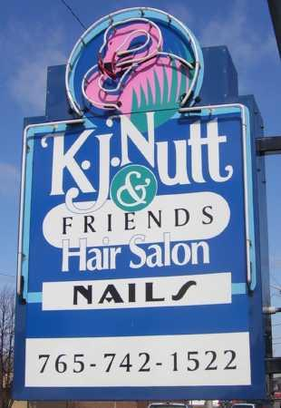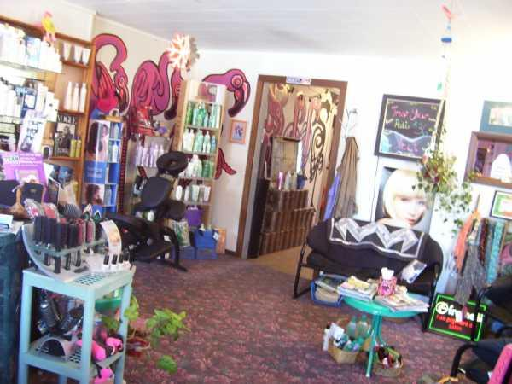

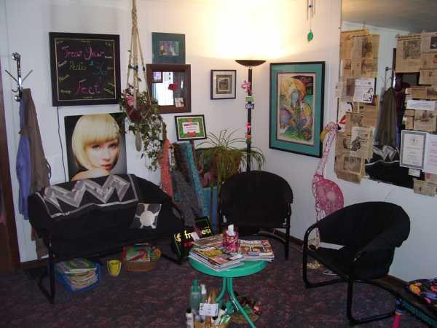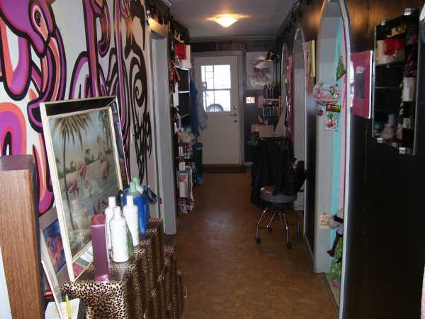

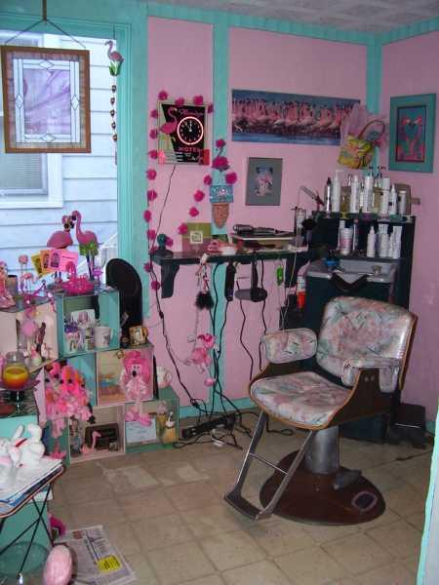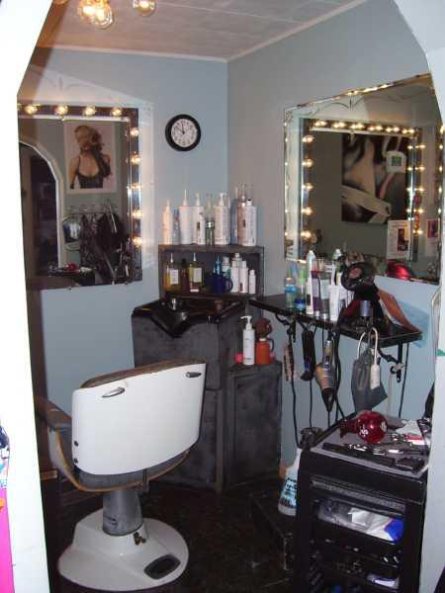

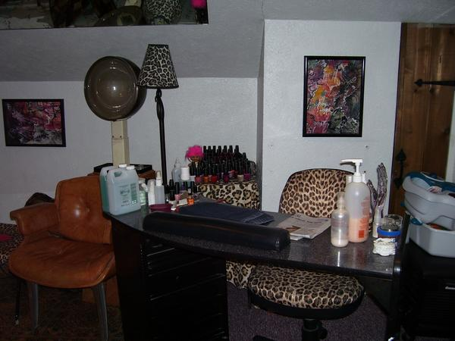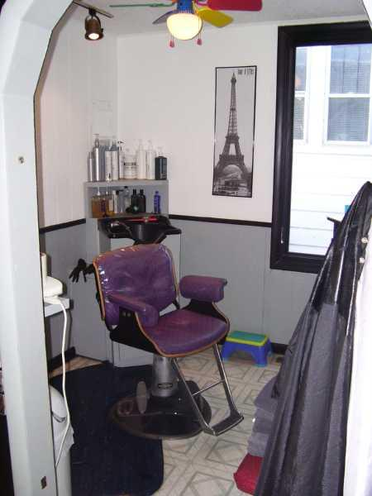

When I first moved to Lafayette in 1993 K. J. Nutt & Friends was one of the very first places I called on for Holy Spirit readings. She did then and still does have an incredible stained glass with 2 lovely Flamingos with their necks intertwined in love and affection. That was what drew me to her salon. They are just beautiful and so striking when you view them as you drive by or from the inside of her salon. My ten years of owning my own stained glass working studio and gallery business always leads me to appreciate stained glass anytime, anywhere I see it.

Adding stained glass to your windows is like adding diamonds of light to your space in a Feng Shui sense. Any stained glass, no matter how small will bring this celebration of light and great Feng Shui Ch'i to you.

Since that time K. J. and I have stayed friends and I would like to recommend her and her staff, Omar and Sage, to you for every type of beauty related service. You can get a cut, a color, a perm, a fabulous massage, your nail work done to perfection; all the while you are enjoying the incredible Feng Shui surroundings. The exotic decor exhibits K. J.'s huge Flamingo collection. The huge painted 6' tall Flamingos are just delightful.

K. J. is a leader in the community with all of the charity work she does to give back. You will enjoy seeing all of the newspaper articles framing the edges of the huge mirror. She is an activist for change and positive living in the Lafayette community and has been for years. Her art is incredibly inspiring and fun. If you love the tropics and excellent salon services go to visit K. J. Nutt & Friends for a real lift for your "look", body, mind and spirit. Tell her I said hello.

You will find all her information at http://www.myspace.com/kjnuttandfriendshairsalon

Lila's Power Feng Shui Inspirations for the Master Bedroom & Hallway

Lila has assembled her very favorite Holy Crosses in the Hallway to lift the energy to a higher spiritual level. She began by centering each of them around a glorious view of the Sun with the bright sky and lovely white billowy clouds. It is a stunning arrangement to bring our thoughts to the life of the Son of God. Lila has used her artistic abilities to Power Feng Shui each of these objects together in her very own statement of Holiness.

The first time I saw it tears filled my eyes. Just by seeing it you simply can feel the Spirituality "radiating" off of the wall. It makes a very clear statement of her beliefs. Using Power Feng Shui to "lift up" your Holy Spirit is a huge blessing not only for Lila, but for all that visit her home.

This double wreath intertwined with dripping grapes is symbolic for new growth and abundance, with double the energy. It is on the Career/Self/Destiny wall in the dining area. The message is abundance for her and her future mate. What a lovely way to express these intentions.

Lila's bedroom is decorated specifically for summoning Prosperity & Good Health (Gold) along with Wealth and Empowerment (Purple). The deep Pink brings good relationships and love. In any bedroom the art icon placed above the bed makes a statement of our intentions. Lila is inviting the beauty and joy of sharing a garden. She enjoys working in her own garden and by displaying this "blooming garden" above her bed the energy will draw someone that has a like kind mindset of appreciation for the beauty she would like to share.

Lila embraced Power Feng Shui immediately and found ways to put her energies into action by "grouping" icons and colors with her decorating abilities. We want to thank her for sharing her "Spiritually inspiring" displays of art. We enjoyed it so much.

Bare Branches or Bamboo Stalks Cure

Everywhere you look whether it is a Neiman Marcus or Horchow catalog or tuned into HGTV to catch the latest trends, you will see bare branches displayed as accents. It is a huge decorator design concept right now and although it is "hot" no one seems to realize that these bare branches literally mean no growth, no prosperity, and scarcity for those that live in the same space. That is the last thing any of us wants.

In order for you to instantly turn this around to "Blooming Love & Empowerment/Wealth you have to visit either Hobby Lobby or any store that has silk flowers for sale. Buy several stems that are joined together to fill a single pot. I bought two bunches of these with the Pink for Love/Relationships and another bunch with the Purple for Wealth and Empowerment. The center of each orchid was Yellow (soft Gold) creating Prosperity and Good Health as well. If you like a lot of blooms of course you would want to buy more on your shopping trip.

I have never seen golden branches in any of these "bare branch" displays so to bring the Prosperity and Good Health to your sacred space you will need to paint them. Buy a Metallic Gold can of Rust-Oleum spray paint and lay the branches out on a large piece of plastic or old newspapers to keep everything from turning gold when you spray them.

Spray them all over and allow them to dry for 30 minutes. When they are dry roll the branches on the protective paper or plastic until you see only the unpainted part visible to you. Spray them Gold. Let them dry for another 30 minutes. Check for any you missed and touch up those. Reposition them in the vase or pottery. To speed up the paint drying you may use your hair dryer if you wish.

Locate your hot glue gun or borrow one. Cut the blooms off of the stems.

Wrap a protective cloth or plastic around the vase or pottery so no drops of hot glue will mar the vessel. Set the vase on some old newspapers or plastic to keep from gluing anything you don't want to glue to the floor. By replacing the branches or bamboo stalks you will know exactly where to position the blooms.

BE CAREFUL OF THE HOT GLUE GUN. They call it hot for a reason. This is not a children's project unless you are doing the gluing yourself while they help you.

Begin to glue the blooms to the branches or stalks in a pattern that is pleasing to you. Use however many look good to you. Space them in a balance all around the arrangement. You can turn the vessel as you attach the blooms to make it easier for you to get the perfect placement.

I chose orchids because they are one to the top Lucky Feng Shui flowers that bring money to the Sacred Home Space or Office Space.

This particular arrangement belongs to Spiritual Fitness Center in Richardson where I teach and attend The Experience (3rd Sunday of each month, 2 PM-7 PM). The Experience is a completely new type of Metaphysical Fair. There are vendors, readers, healers and many unusual options. Come by and say hello some 3rd Sunday. You will love it. You can find out more at www.SpiritualFitnessCenter.com, Calendar of Events. Classes are offered all month long with a variety of subject matter. Check it out for yourself. If you are on a spiritual growth plane and desire to get to a higher level, this is the place to do it.

I went to Spiritual Fitness Center one afternoon a few months ago armed with my Gold Metallic Rust-Oleum, flowers, glue gun, plastic sheeting, wire cutters to cut the flowers from the stems, and a determination to see what a "cure" would do for those bare branches. It took less than two hours time altogether.

I saw them about a week after I did this and Sunnie Murphy, co-owner of Spiritual Fitness, told me that the next day they had booked 42 different events with one client for the next two months. As you might imagine, I was thrilled.

Not only did it "cure" the bare branches, it actually brought income immediately to the Spiritual Fitness Center. This was proof enough to me that working a "cure" on simply anything with Power Feng Shui will refresh, inspire, and expand the energies to the highest level for whatever our intentions may be. This is a fun, quick and effective "cure" you can create for very little expense and a little bit of time.

Look around your Sacred Space and see what needs to be "cured". You might be surprised when you look with "Feng Shui eyes" to see what might be holding you back from your dreams. Experiment with moving objects around the room to see what might happen if you change things. Sometimes you just need the right intention to bring the results to you. Give it a try. You will be pleasantly surprised. Have fun with your Power Feng Shui.

"Blooming Garden"

A concrete jungle made up of blocks of commercial and residential buildings cannot stop a "Blooming Garden" from changing the Ch'i in Downtown Dallas's own Deep Elm Arts District with outdoor mural art.

Water lilies are another very lucky flower with Feng Shui. Adding "lucky" water lilies to the back of this building with a virtual and visible window "opens up" a whole new compliment of Pink (Love/Relationship) blooms, and Green (Wood Element for new growth; also Family/Community) leaves. The Black Career/Self/Destiny outlines of the faux stained glass design concept not only frame the design with a gracious flow, they weave their way through the dramatic concept, they bring Career/Self/Destiny to the lucky water lilies growth for Love and Family and Community.

It is very uplifting to drive through Deep Ellum and see original art concepts painted on the buildings. Drive by if you get a chance. You won't regret it.

PEACE... clearly visible in the darkness of night...

When driving through the little town of Battleground, IN. if you turn down the right street at night suddenly you see a Hot Pink Peace Symbol floating directly above the entrance of this house. In total darkness I drove by one night, and was pleasantly surprised to see the color of Love and Relationships fashioned into a neon symbol proclaiming the concept of being "at peace" in our lives and loves. I "knew" a 60's survivor had placed it there to continue to encourage others to consider "Give Peace a Chance" as they pass by.

The Hot Pink "fires up" the Love and Relationships for those that live there and also those that drive by. By combining it with the concept of "Peace" this sign is "firing up" the peace inspiration. The Peace Sign is like a beacon in the night with its Hot Pink glow.

Days later I found I was still thinking about "Peace on Earth" and how if we all did our part it would be so wonderful. As they say at church, let the peace begin with you.

Thanks again for being a part of our September EZine from www.PowerFengShui.info

Alexandra Shaw
CEO

If you no longer wish to receive this publication please email Iconalex@aol.com and we will happily remove you.

New MapQuest Local shows what's happening at your destination. Dining, Movies, Events, News & more. Try it out!

